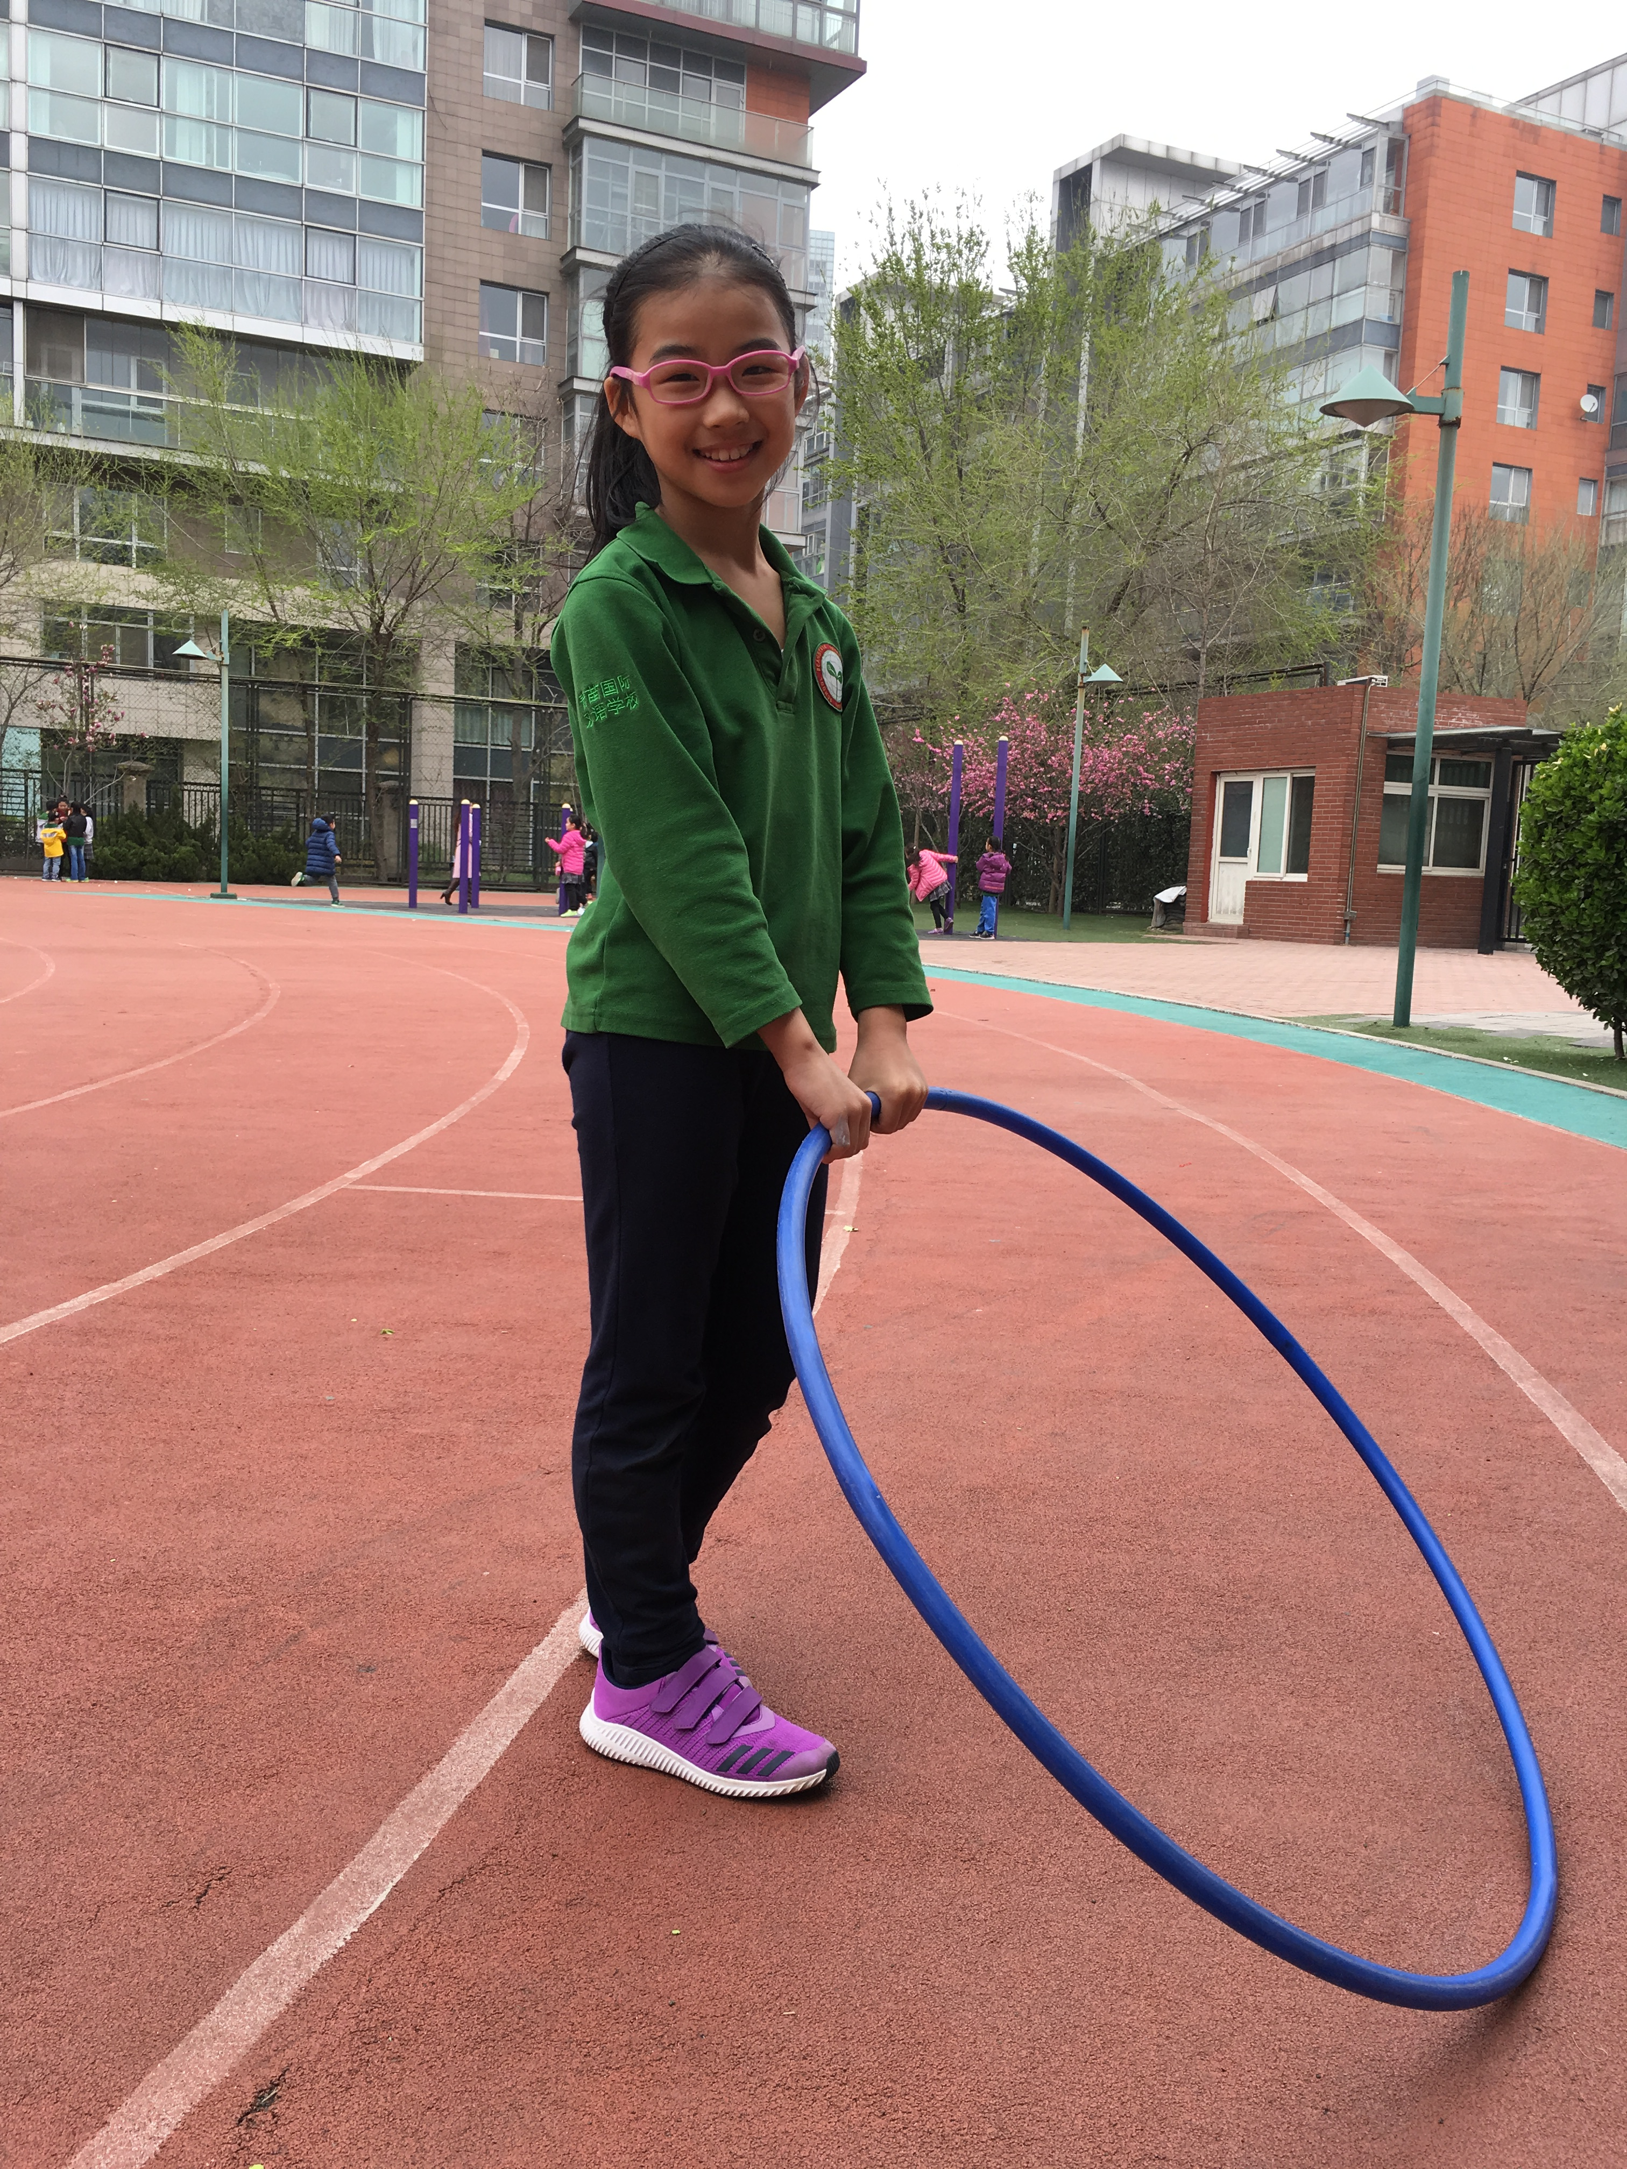

#### *(Name)* is a *(Learner Profile)* student in PE. During our *(Unit)* unit, *(Name)* was able to look back at her team’s performance and found ways to improve their teamwork. Her formative and summative assessments were astoundingly done and demonstrated a thorough understanding of what it means to be a positive team player. Congratulations, *(Name)*!

#### The Learner Profile in PE Award

### UOI _

### Grade __

# *(First & Last name)*

###### MVP

### *(Learner Profile)*

###### 2017